Test Analyst Week 3 Day 1 Assignment

- Build Create a new record in the Time and Material module
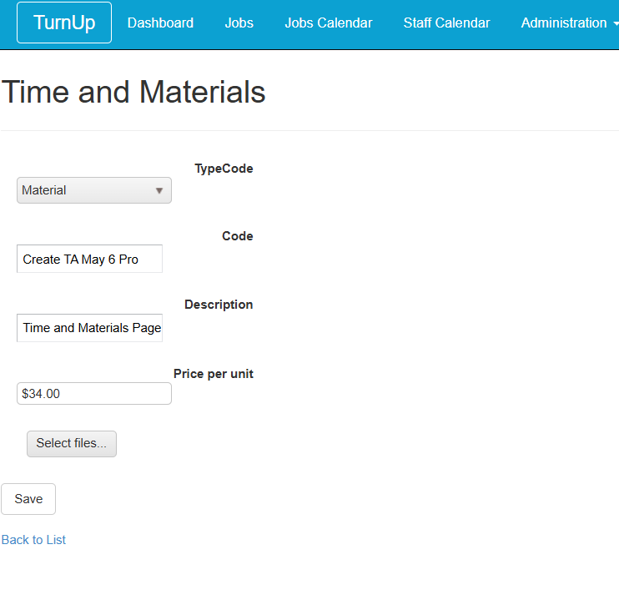
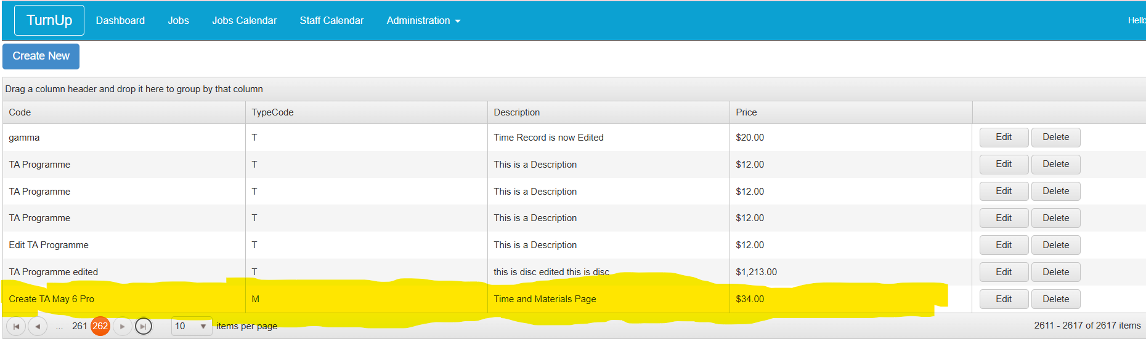

------------------------------------------------------------------------------------------------------------------------

- Build Edit new record in the Time and Material module
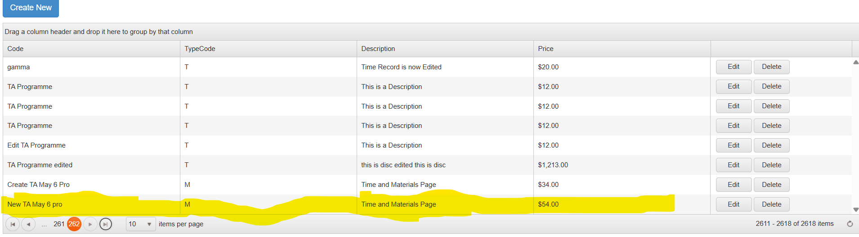
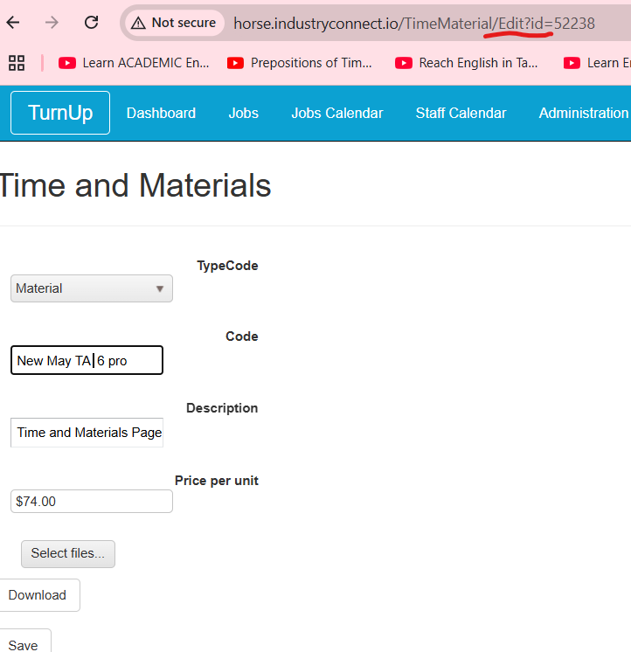

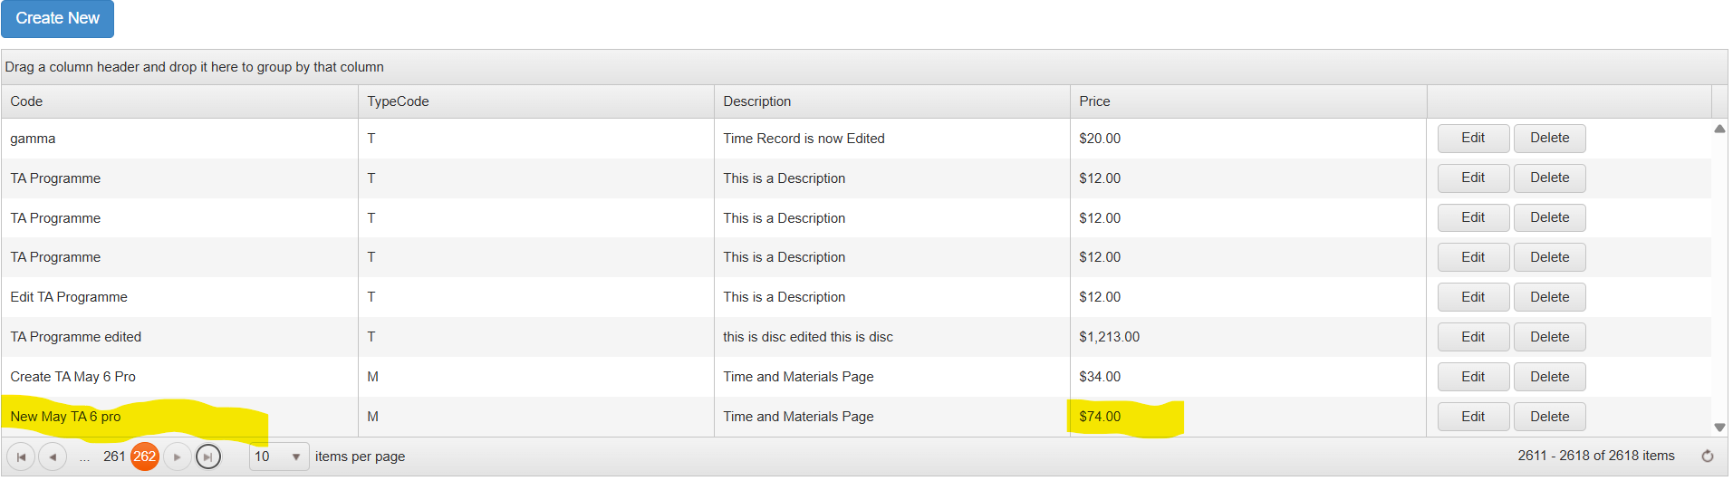

---------------------------------------------------------------------------------------------------------------------
- Build Delete new record in Time and Material module

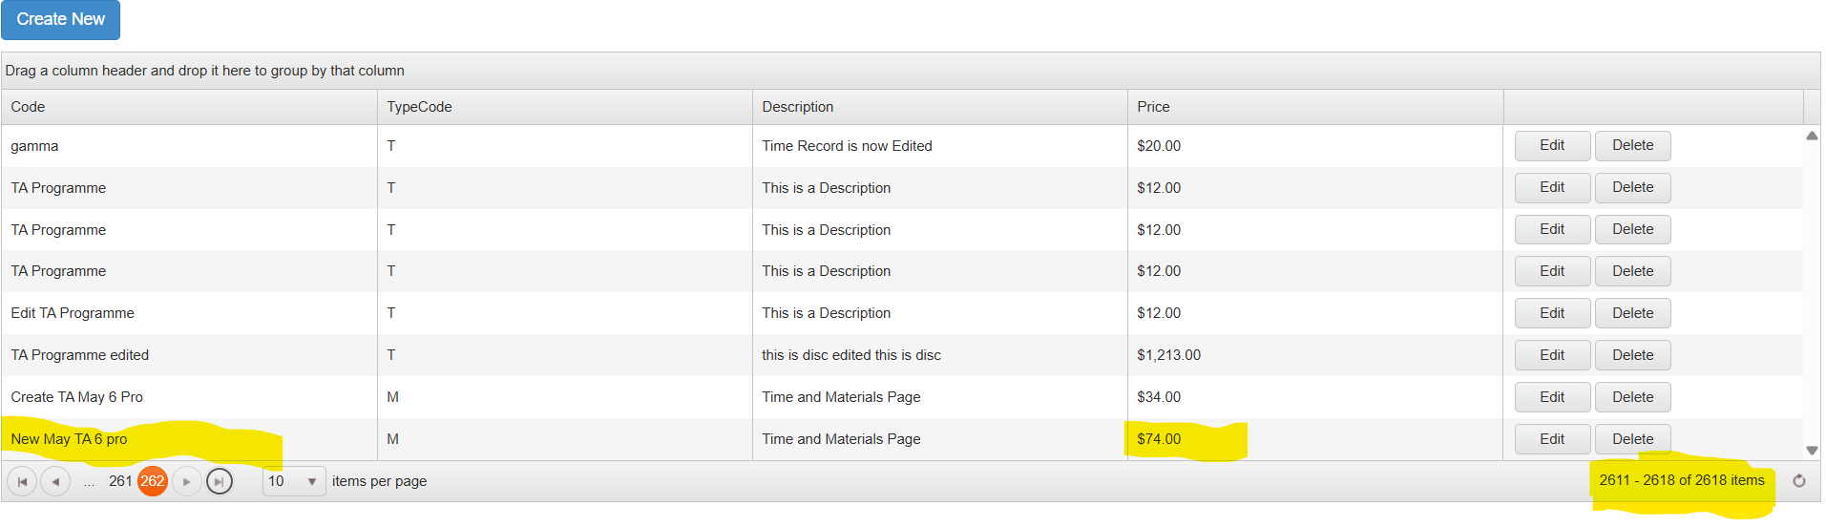

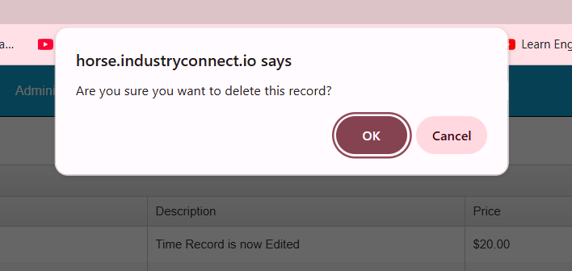

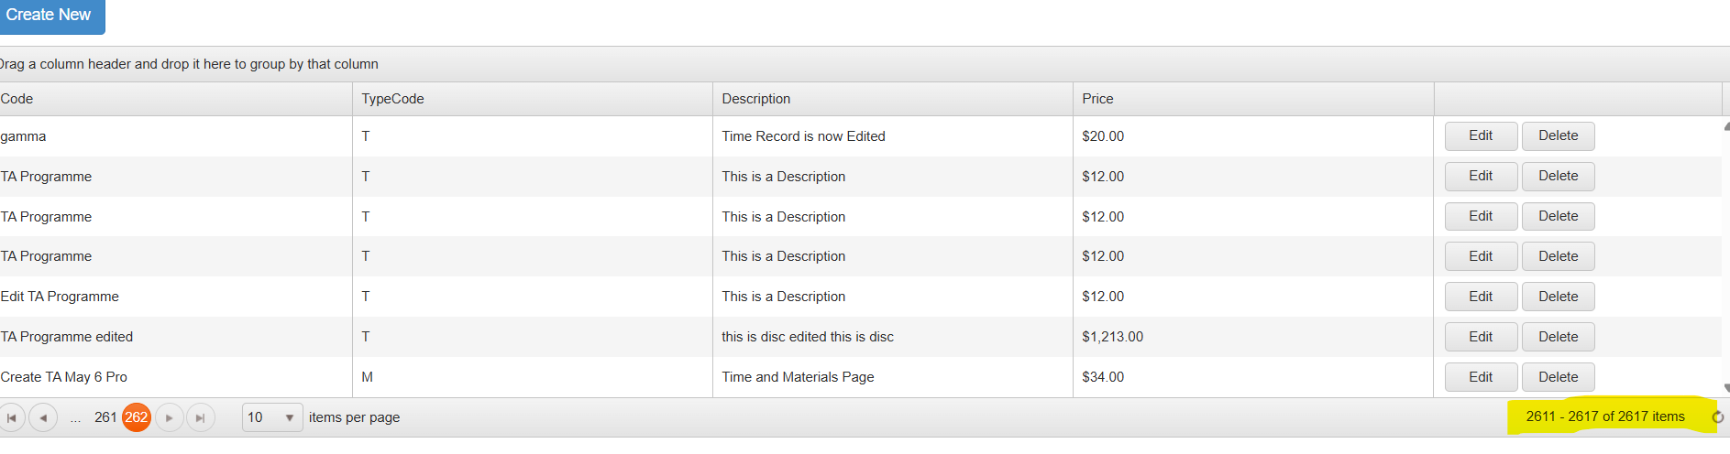

- Build Create, Edit, Delete flows for any other module
Employee Table Edit
Employee Table Create 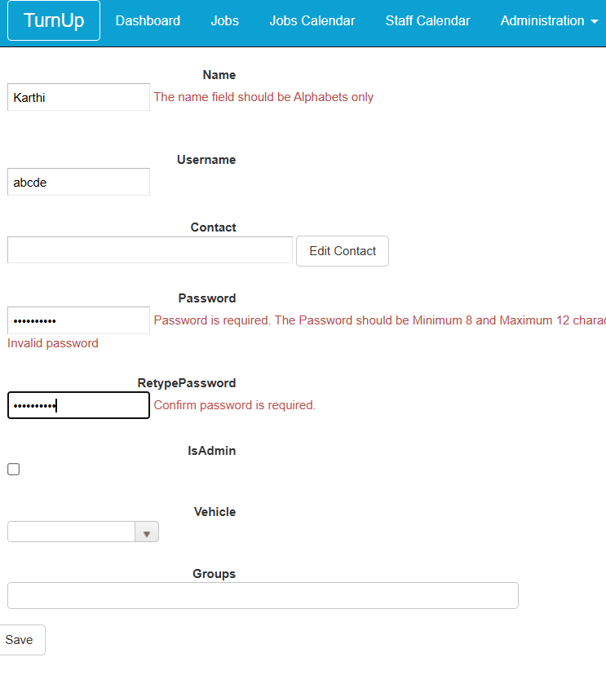
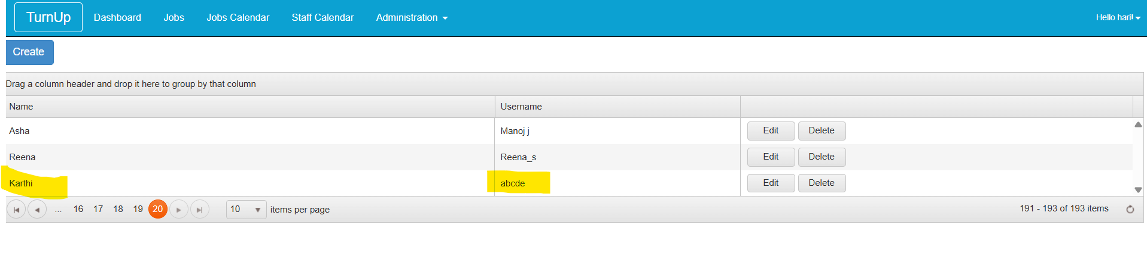

Employee Table Edit
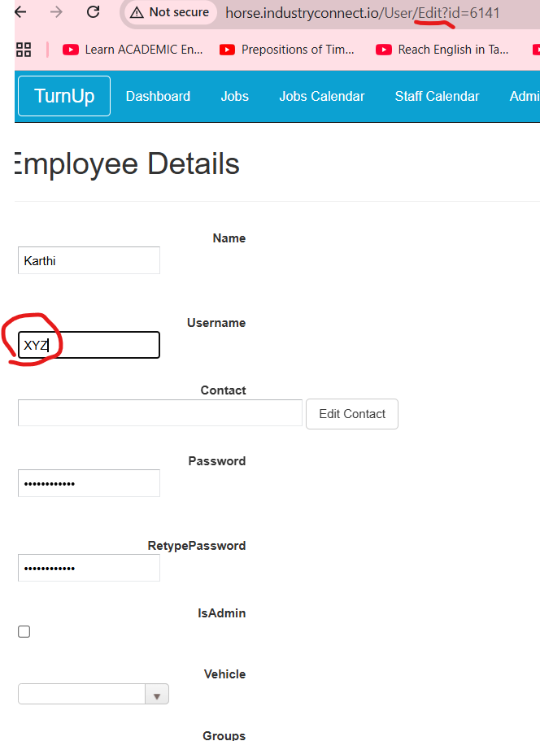

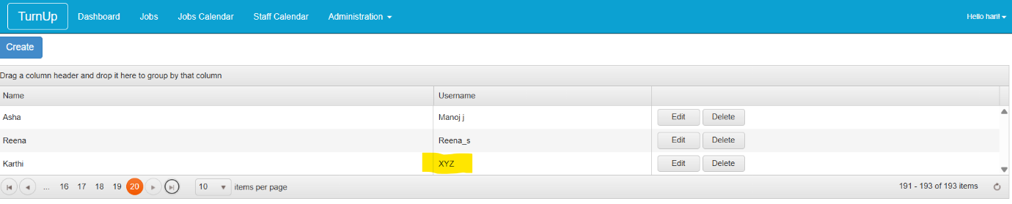

Employee Table Delete

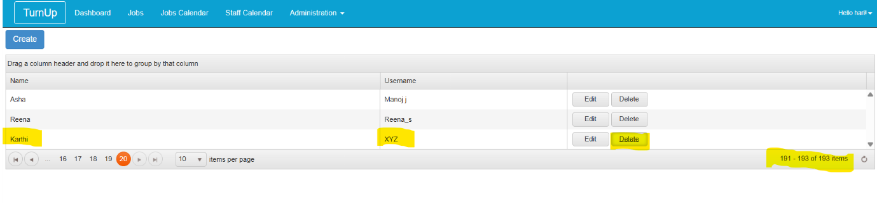
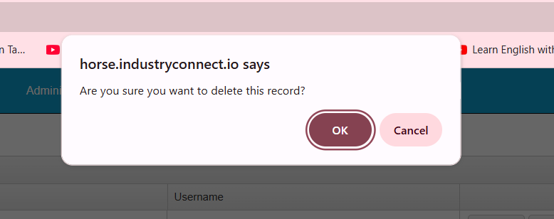

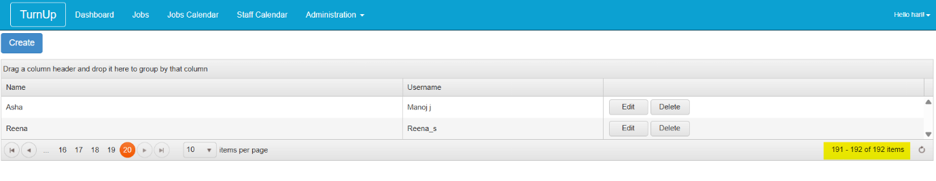
-------------------------------------------------------------------------------------------------------------------

- Search in Google: How to interact with pop up C# selenium

How to handle Alerts and Popups in Selenium?
Assume you are filling out an application form and miss out on a few details mistakenly. How do you know this unless there is an alert or a pop-up window to notify you? This article discusses in detail what is an alert in selenium and how to handle them.
To get hands-on how to handle alerts and popups in Selenium, let’s dive deeper into the below-mentioned topics.
What are Alerts in Selenium?
Alert in Selenium is a message/notification box that notifies the user about some information or asks for permission to perform a certain kind of operation. It may be used for warning purposes as well.
Types of Alerts in Selenium
There are three types of Alert in Selenium, described as follows:
- Simple Alert
- Prompt Alert
- Confirmation Alert
1. Simple Alert
This alert is used to notify a simple warning message with an ‘OK’ button, as shown in the below snapshot.
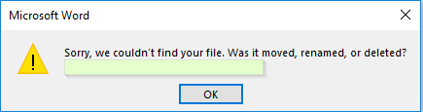
2. Prompt Alert
This alert will ask the user to input the required information to complete the task. In the below snapshot, you can see that without entering the destination for Hotel, you are not allowed to hit the search button.
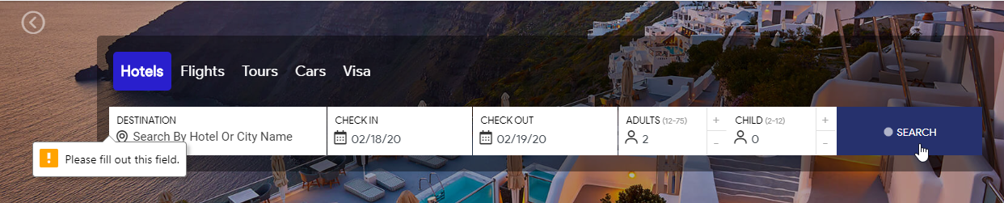
Now, this input can be entered with the help of sendKeys(“input_text”) method in Selenium Webdriver.
3. Confirmation Alert
This alert is basically used for the confirmation of some tasks. For Example: Do you wish to continue a particular task? Yes or No? The snapshot below depicts the same.
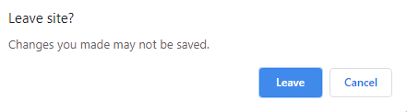
Now that you know what are alerts in selenium and its types, let’s move further and understand how to handle alerts in selenium.
Also Read: Selenium Commands every Developer or Tester must know
How to Handle Alerts in Selenium?
Handling alerts manually is a tedious task. To reduce human intervention and ease this task, Selenium provides a wide range of functionalities and methods to handle alerts.
The following methods are useful to handle alerts in Selenium:
1. Void dismiss(): This method is used when the ‘Cancel’ button is clicked in the alert box.
driver.switchTo().alert().dismiss();
2. Void accept(): This method is used to click on the ‘OK’ button of the alert.
driver.switchTo().alert().accept();
3. String getText(): This method is used to capture the alert message.
driver.switchTo().alert().getText();
4. Void sendKeys(String stringToSend): This method is used to send data to the alert box.
driver.switchTo().alert().sendKeys("Text");

